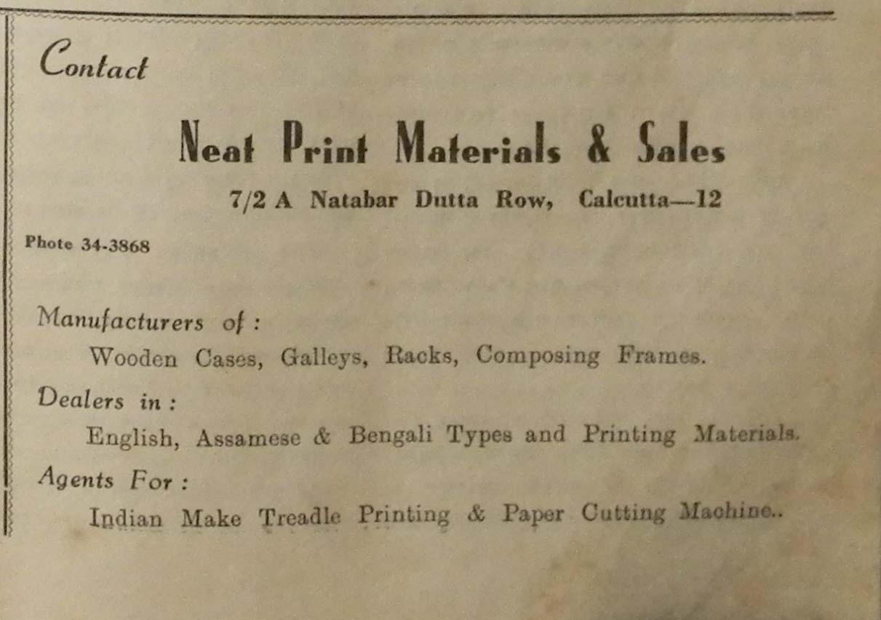

Item*: Print Materials & Sales advert*

Category: Print materials

Company: Neat Print Materials & Sales, Calcutta

Source: *Monideep* 1963

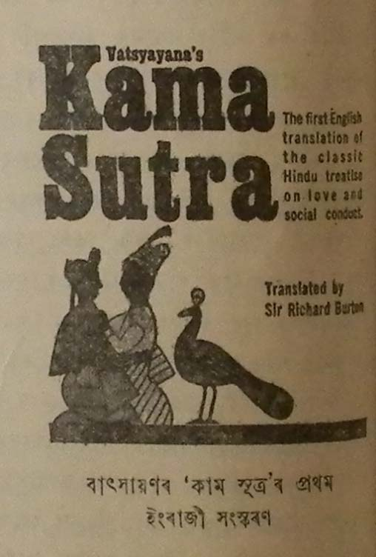

*Kama Sutra First English translation advert*

Book

*Monideep* 1963

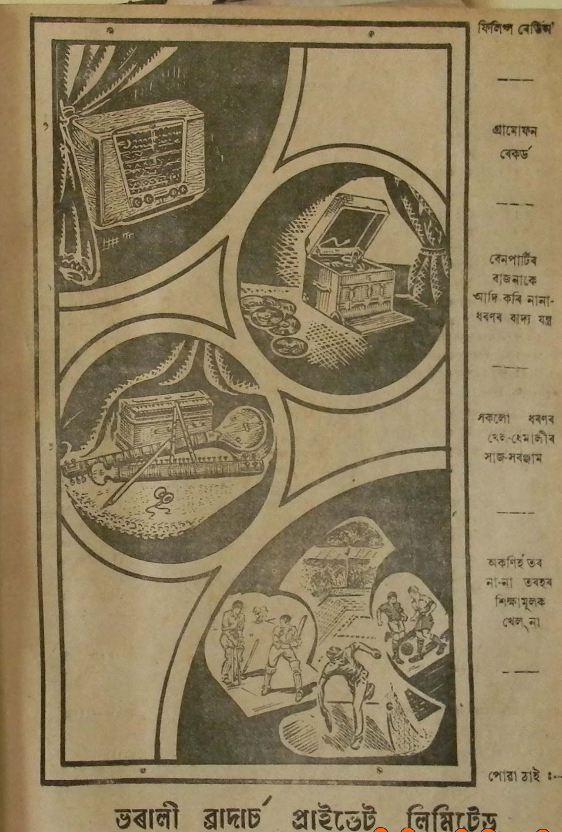

Electronics, sports goods *advert*

Bharali Brothers’ Private Limited, Gauhati

*Ramdhenu* 1956

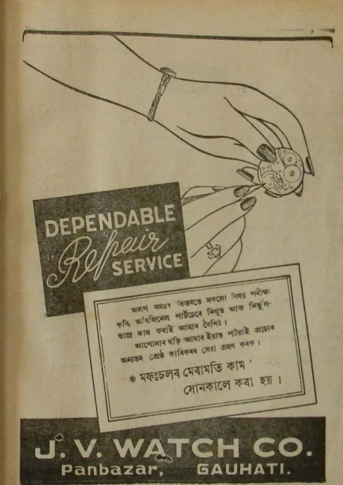

*Dependable Repair Service advert*

Watch / clock repair

J.V.Watch Company, Gauhati

*Ramdhenu* 1956

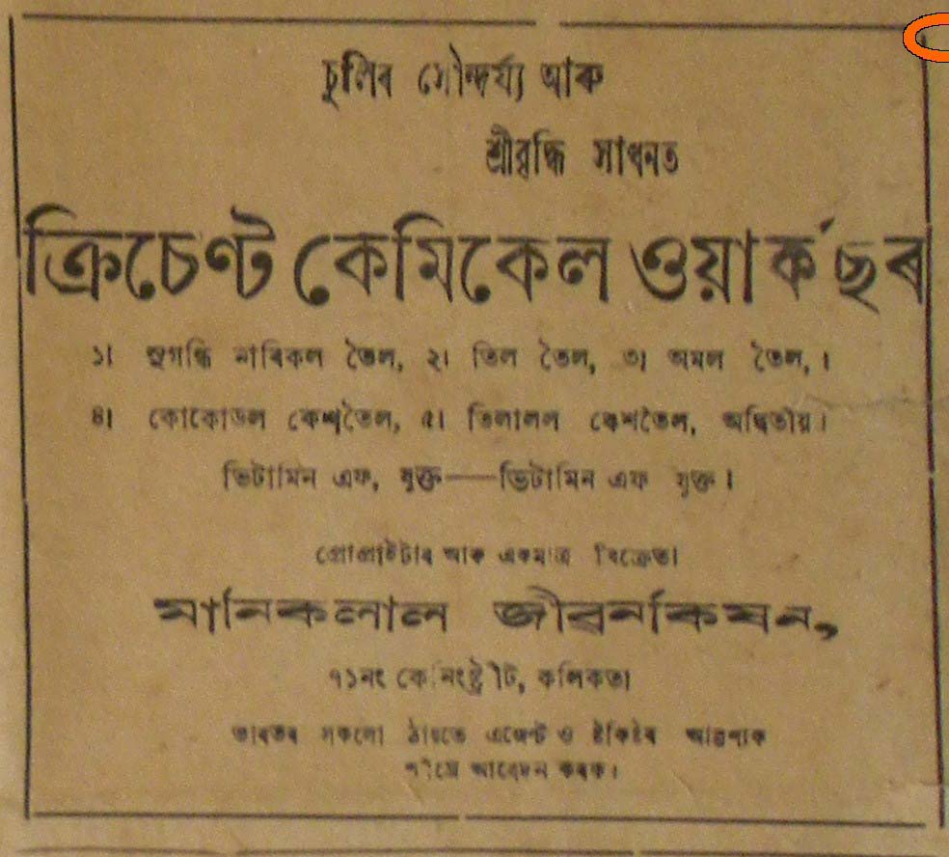

*Crescent Chemical Works advert*

Oil (perfumed coconut oil, Assam oil, *Til* oil etc)

Maniklal Jivankisan, Calcutta

*Sadinia Asomiya* 1945

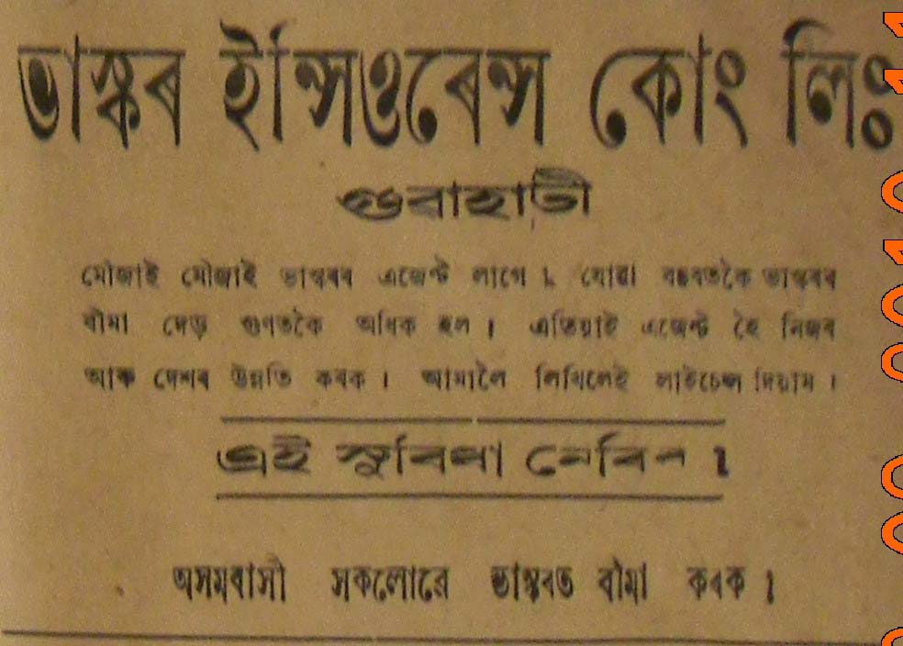

*Bhaskar Insurance Cooperation Limited advert*

Insurance

Bhaskar Insurance Cooperation Limited, Gauhati

*Sadinia Asomiya*, 1945

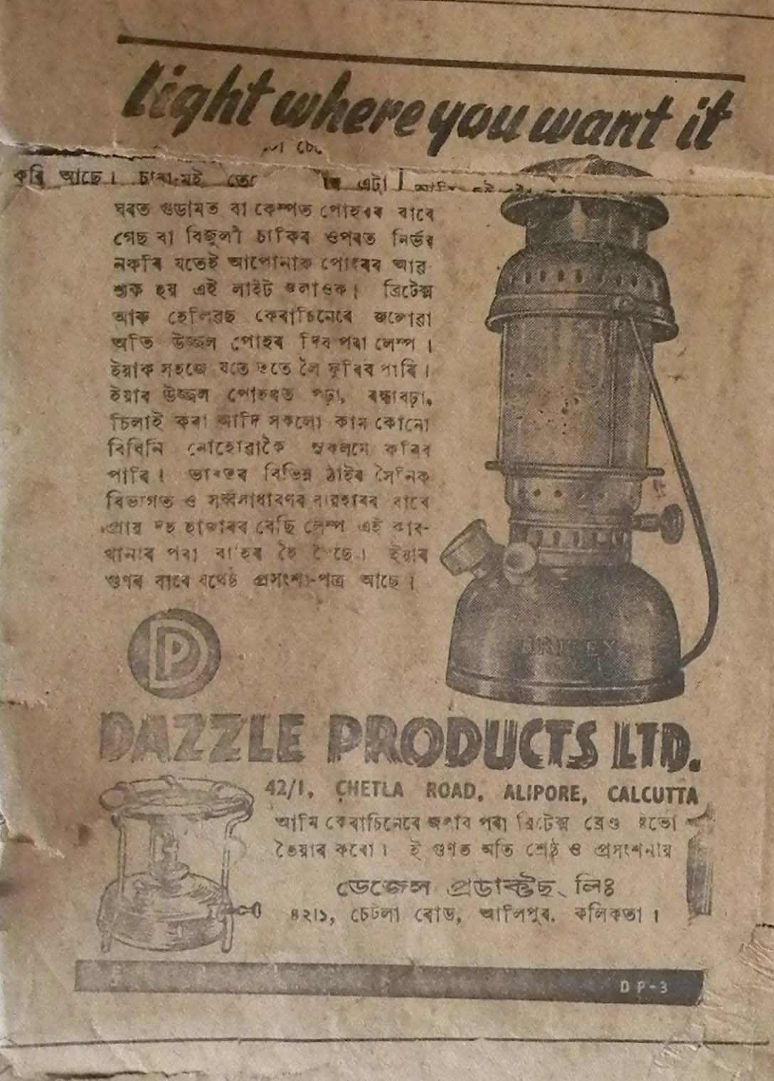

*Dazzle Products Ltd advert*

Oil lamp

Dazzle Products Ltd, Calcutta

*Sadiniya Asomiya*, 1945,

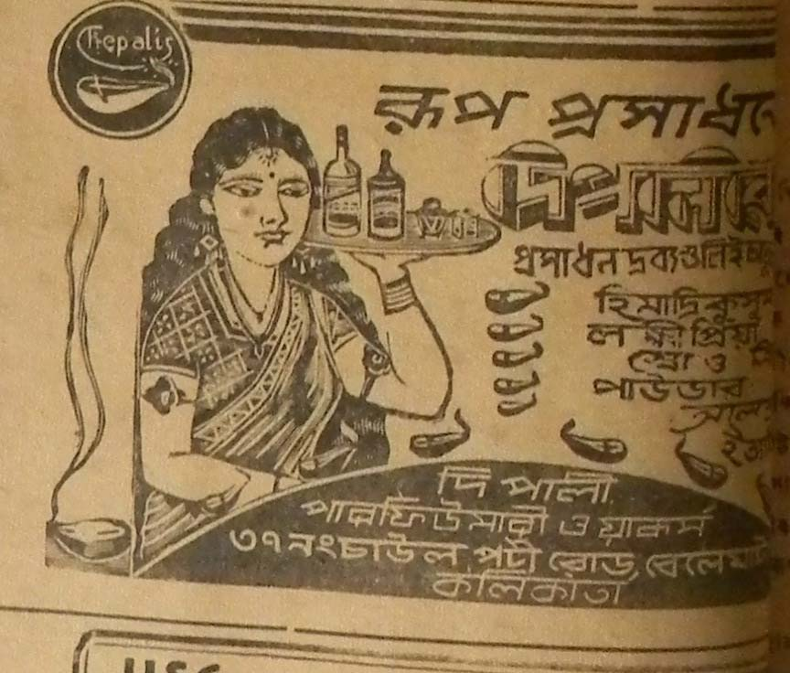

*Dipali Perfumery Works advert*

Cosmetic products

*Sadiniya Asomiya*, 1945

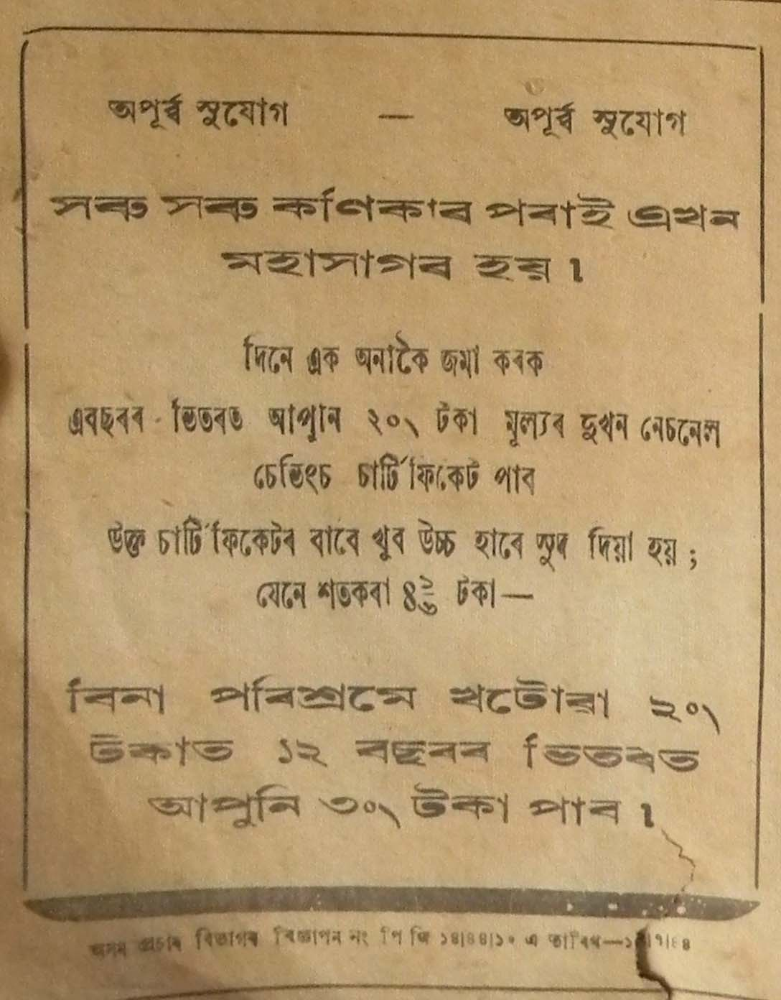

*Assam Publicity Department advert*

National Savings Scheme

*Sadiniya Asomiya* 1945

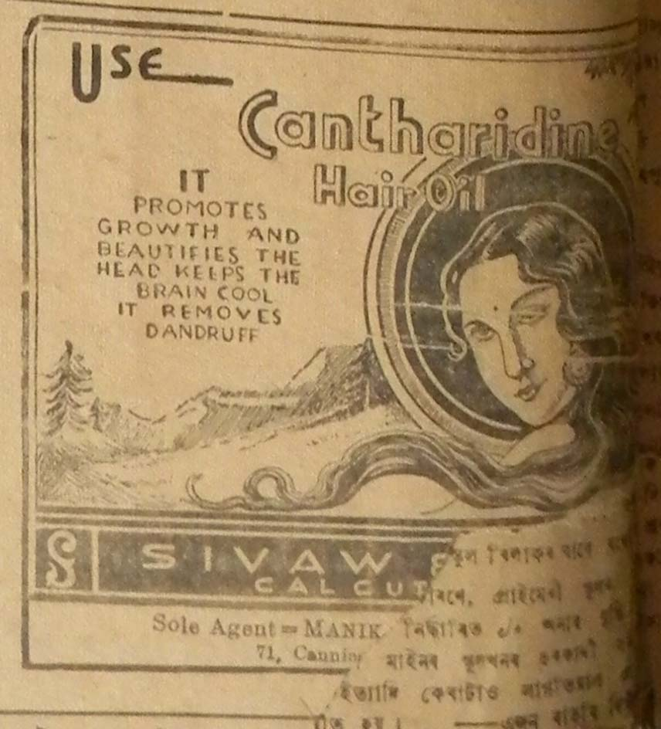

*Cantharidine Hair Oil advert*

Cosmetic products

*Sadiniya Asomiya,* 1945

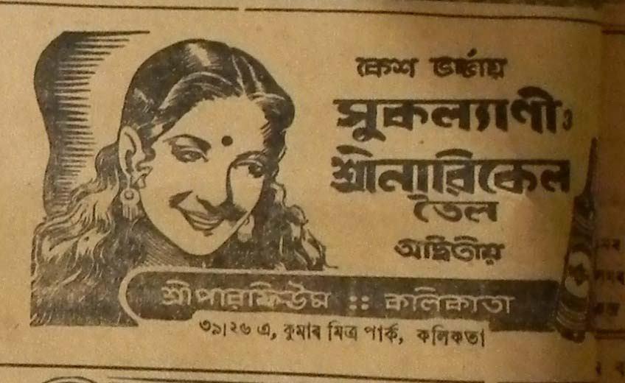

*Sukalyani Hair oil advert*

Cosmetic products

Shriperfume, Calcutta

*Sadiniya Asomiya* 1945

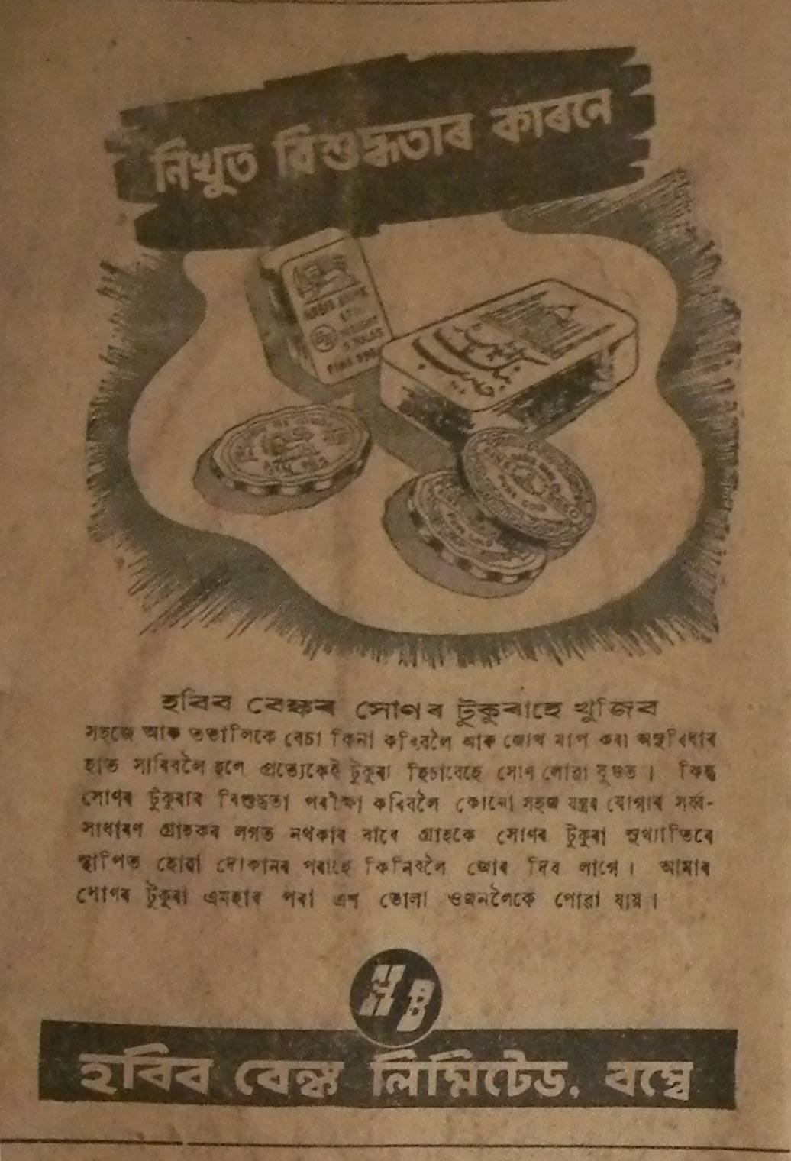

*Habib Bank advert*

Gold

Habib Bank Limited, Bombay

*Sadiniya Asomiya* , 1945

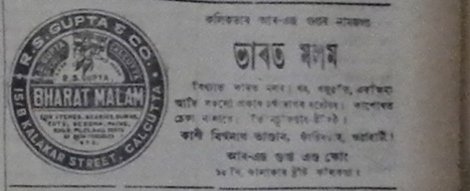

*Bharat Malam (ointment) advert*

Medicine

*Sadiniya Asomiya* ,1947

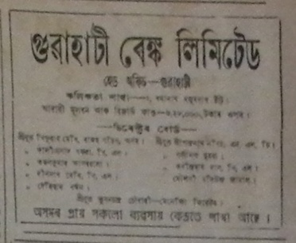

*Guwahati Bank advert*

Banks

*Sadiniya Asomiya*, 1947

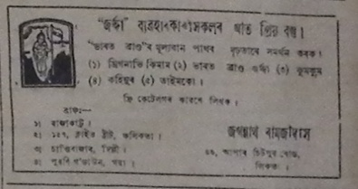

*Bharat Brand advert*

Tobacco

*Sadiniya Asomiya*, 1947

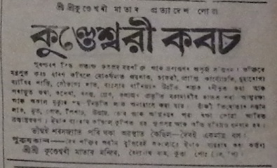

*Kundeswari Kawas advert*

Amulet

Shri Shri Kundeswari Mata Mandir (Temple)

*Sadiniya Asomiya*, 1947

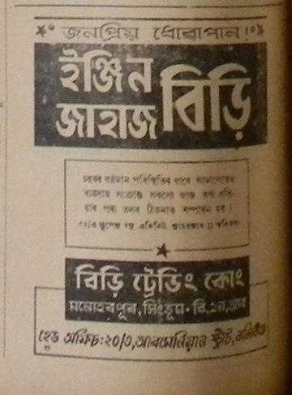

*Engine Jahaj Bidi advert*

Tobacco

Bidi Trading Company, Calcutta

*Sadiniya Asomiya*, 1947

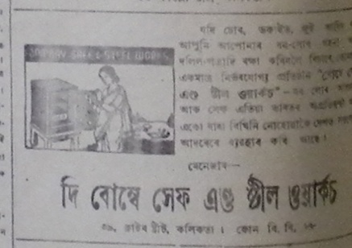

*The Bombay Safe and Steel Works advert*

Furniture

*Sadiniya Asomiya,* 1947

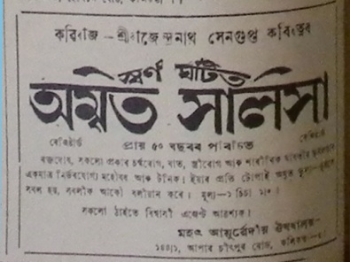

*Amrit Salsa advert*

Ayurvedic medicine

Mahat Ayurvedic Aushadhalay, Calcuta

*Sadiniya Asomiya*, 1947

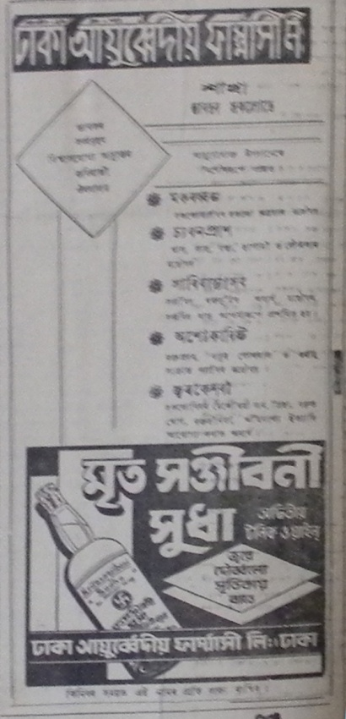

*Mrita Sanjivani Shudha advert*

Ayurvedic medicine

Dhaka Ayurvediya Pharmacy Limited

*Sadiniya Asomiya*, 1947

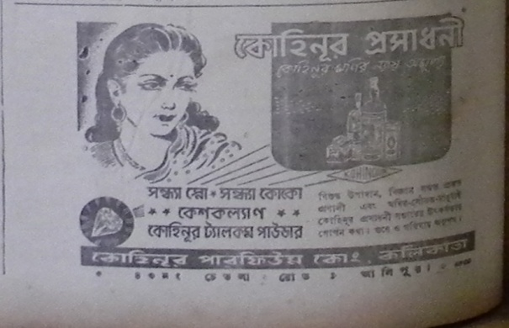

*Kohinoor Company Cosmetics advert*

Cosmetic products

Kohinor Perfume Company, Calcutta

*Sadiniya Asomiya* 1947

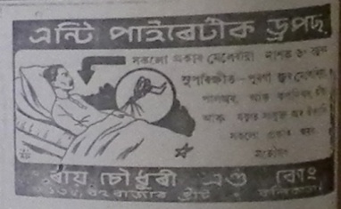

*Anti-pyretic drops advert*

Raichoudhury and Company

Medicine

*Sadiniya Asomiya* 1947

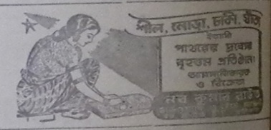

**Sadiniya Asomiya, 8th nov 1947, pg4**

***Naba Kumar Raut***

**This is an advertisement of a shop where fine quality of grinding stone and other items are found.**

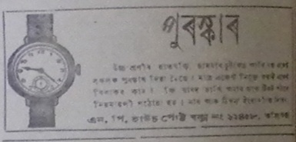

**Sadiniya Asomiya, 8th nov 1947, pg4 copy 4**

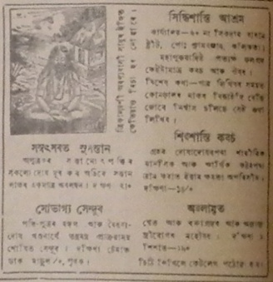

**Sadiniya Asomiya, 9th August 1947, pg 6**

***Siddhisantiashram***

**It is an advertisement of a monastic establishment.**

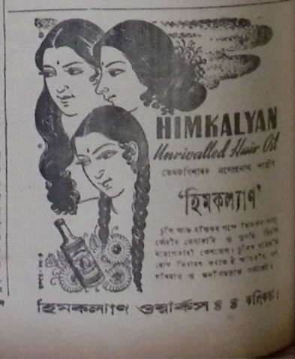

**Sadiniya Asomiya, 9th August 1947, pg 6**

***Himkalyan Works***

**It is an advertisement on Himkalyan hair oil.**

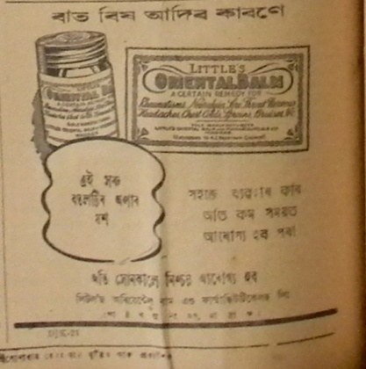

**Sadiniya Asomiya, 9th August 1947, pg 8**

***Little’s Oriental Balm***

**It is an advertisement on pain relief balm.**

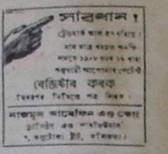

**Sadiniya Asomiya, 10th may 1947, pg 8**

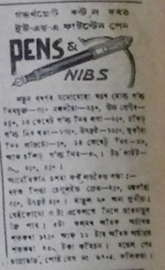

**Sadiniya Asomiya, 10th may 1947, pg 8**

***Pens & Nibs***

**It is an advertisement on U.S.A. fountain pen**

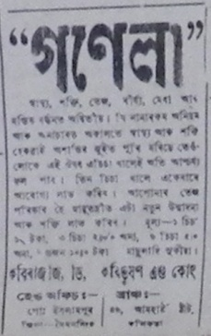

**Sadiniya Asomiya, 10th may 1947, pg 8**

***Kabiraj D., Kabibhusan and Company***

**It is an advertisement on the *Gonela* medicine.**

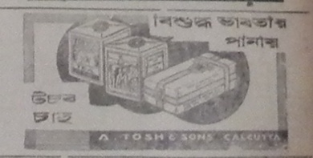

**Sadiniya Asomiya, 11 magh, 1869 saka, pg 3 and Sadinia Asomiya,3rd march. 1945, pg8 and Sadinia Asomiya,10th march. 1945, pg7**

***Pure Indian Drink***

**It is an advertisement on *Usab Tea***

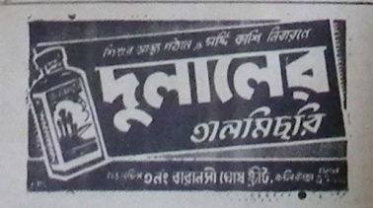

**Sadiniya Asomiya, 11 magh, 1869 saka, pg 3 copy and Sadiniya Asomiya,26th april 1947 pg3 and Sadiniya Asomiya, 6th dec 1947, pg 3**

***Dulaler Talmishri***

**It is an advertisement on cough syrup.**

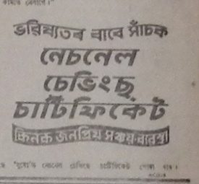

**Sadiniya Asomiya, 11 magh, 1869 saka, pg 3copy2 and 10th january 1948 pg 5**

***National saving certificate***

**It is an advertisement on saving scheme.**

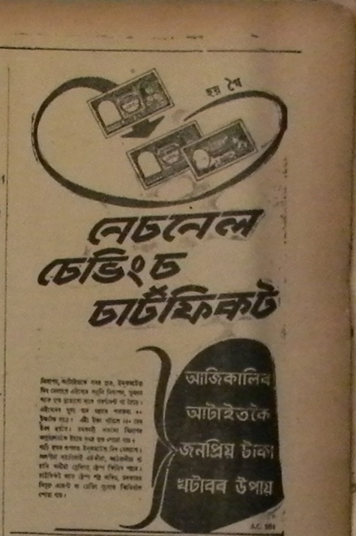

**Sadiniya Asomiya, 12th july 1947, pg 3**

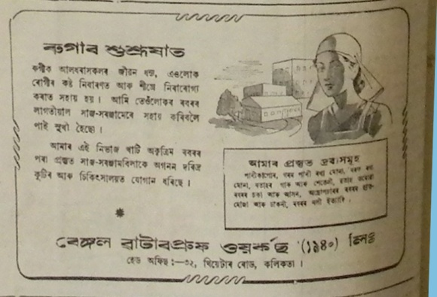

**Sadiniya Asomiya, 13th march, 1948. pg6**

***Bengal Waterproof Works***

**It is an advertisement on medical equipments.**

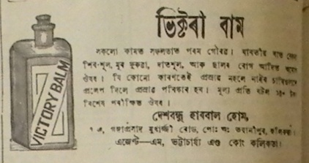

**Sadiniya Asomiya, 13th march, 1948. pg6 c1 and Sadiniya Asomiya, 13th march, 1948. pg6 c2 n Sadiniya Asomiya, 9th August 1947, pg 6**

***Deshbandhu Herbal Home***

**It is an advertisement on pain relief balm.**

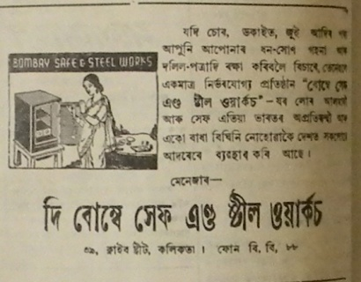

**Sadiniya Asomiya, 13th march, 1948. pg6 c3**

***The Bombay Safe and Steel Works***

**This is an advertisement of almirahs and shelves**

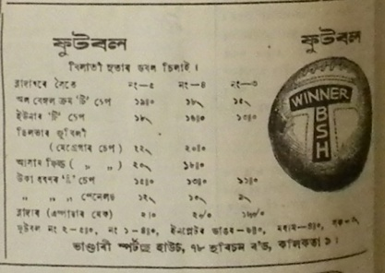

**Sadiniya Asomiya, 13th march, 1948. pg6**

***Bhandari Sports House***

**This is an advertisement on sports equipments such as football.**

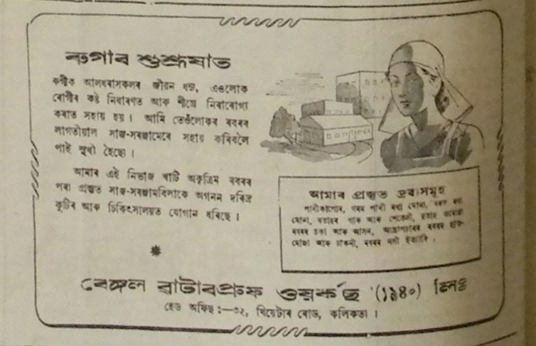

**Sadiniya Asomiya, 13th march, 1948. pg6**

***Bengal Waterproof Works***

**It is an advertisement on medical equipments.**

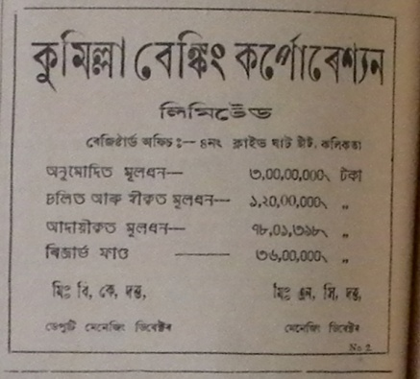

**Sadiniya Asomiya, 13th September 1947, pg4**

***Kumilla Banking Corporation Limited***

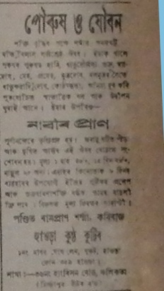

**Sadiniya Asomiya, 15th nov 1947, pg5 copy4**

***Pandit Rampran Sharma Kaviraj***

**It is an advertisement on herbal medicine to make one feel younger.**

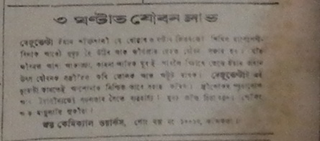

**Sadiniya Asomiya, 15th nov 1947, pg5 copy8**

***Joi Chemical Works***

**It is an advertisement of *Bejuvelta* medicine which will make you feel younger and lively within three hours.**

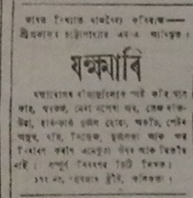

**Sadiniya Asomiya, 15th nov 1947, pg5**

***Zakhmari***

**It is an advertisement on herbal medicine to cure diseases.**

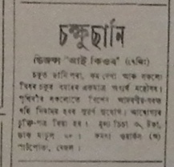

**Sadiniya Asomiya, 15th nov 1947, pg5**

***Visio Eye Cure***

**It is an advertisement of an eye clinic.**

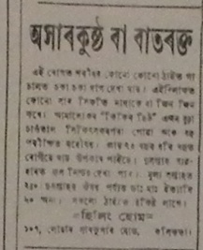

**Sadiniya Asomiya, 15th nov 1947, pg5**

***Healing Home***

**It is an advertisement of a clinic to cure diseases like *akharkustha* or  *batrakta***

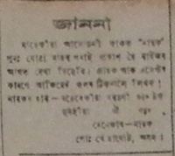

**Sadiniya Asomiya, 15th nov 1947, pg5 copy 5**

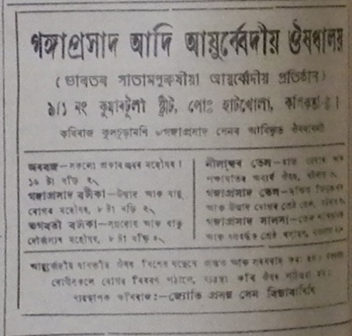

**Sadiniya Asomiya, 22nd nov 1947, pg4**

***Ganga Prashad Adi Ayurvediya Aushadhalaya***

**It is an advertisement on ayurvedic medicine.**

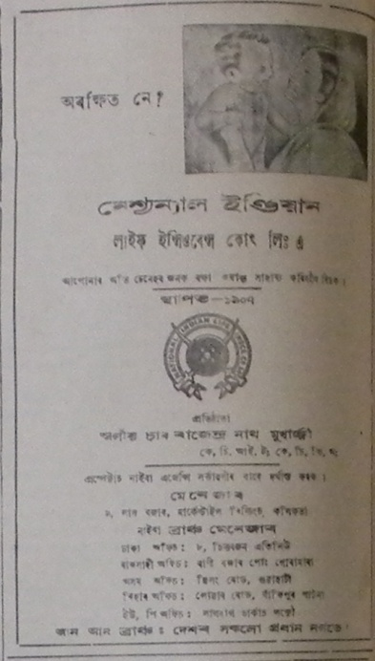

**Sadiniya Asomiya, 22nd nov 1947, pg4**

***National India Life Insurance Company Limited***

**It is an advertisement on insurance schemes.**

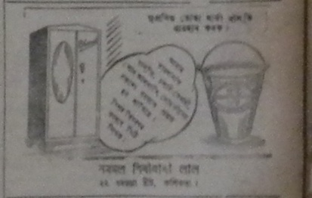

**Sadiniya Asomiya, 22nd nov 1947, pg5 and Sadiniya Asomiya, 6th dec 1947, pg4**

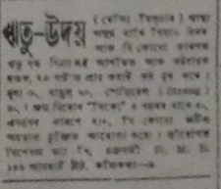

**Sadiniya Asomiya, 22nd nov 1947, pg5**

***Ritu Udoy***

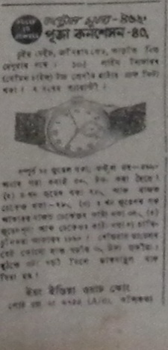

**Sadiniya Asomiya, 22nd nov 1947, pg5 copy 2 and Sadiniya Asomiya, 23rd August 1947, pg 8**

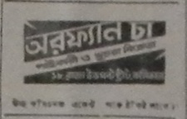

**Sadiniya Asomiya, 22nd nov 1947, pg5 copy 3**

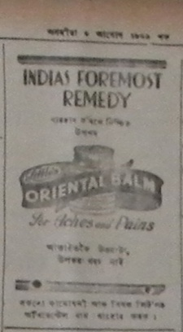

**Sadiniya Asomiya, 22nd nov 1947, pg5**

***Oriental Balm***

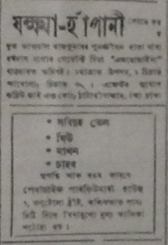

**Sadiniya Asomiya, 22nd nov 1947, pg5**

***Zakhma-Hapani***

**It is an advertisement about medicine to cure tuberculosis and asthmatic trouble.**

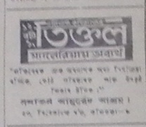

**Sadiniya Asomiya, 23rd August 1947, pg2**

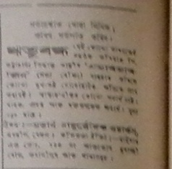

**Sadiniya Asomiya, 23rd August 1947, pg2 c2**

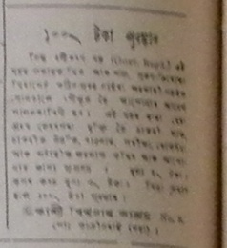

**Sadiniya Asomiya, 23rd August 1947, pg2 c6**

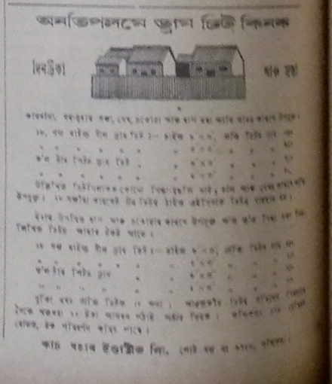

**Sadiniya Asomiya, 23rd August 1947, pg2**

***Dram Sheet***

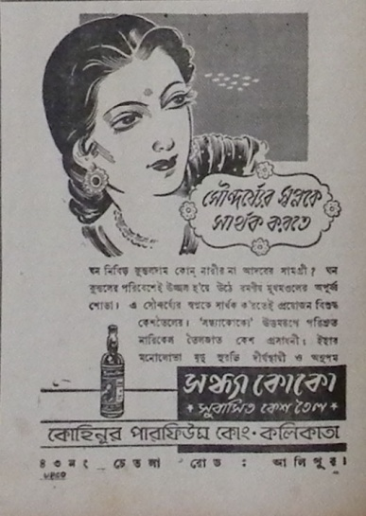

**Sadiniya Asomiya, 23rd August 1947, pg 2**

***Kohinor Perfume Company, Calcutta***

**It is an advertisement on *Sandhya Kuku* hair oil.**

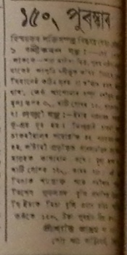

**Sadiniya Asomiya, 23rd August 1947, pg 8 c3**

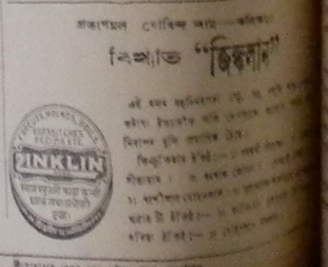

**Sadiniya Asomiya, 23rd August 1947, pg 8**

***Zinklin***

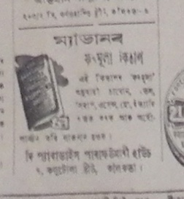

**Sadiniya Asomiya, 23rd August 1947, pg 8 c7**

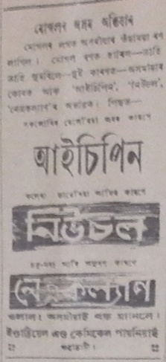

**Sadiniya Asomiya, 23rd August 1947, pg 8 copy 2**

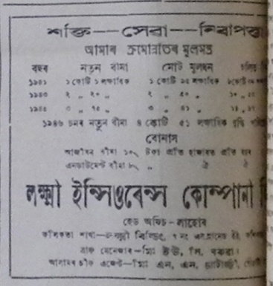

**Sadiniya Asomiya, 24th may 1947, pg 2**

**Laxmi Insurance Company Limited**

**It is an advertisement on insurance scheme.**

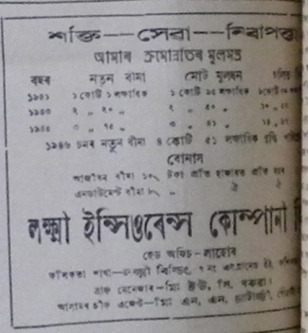

**Sadiniya Asomiya, 24th may 1947, pg 2 copy**

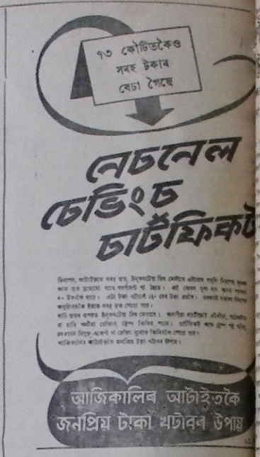

**Sadiniya Asomiya, 24th may 1947, pg 2 copy 2 and Sadiniya Asomiya, 24th may 1947, pg 2**

***National Savings Certificate***

**It is an advertisement on saving scheme by an insurance company**

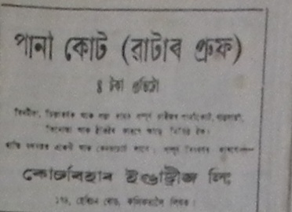

**Sadiniya Asomiya, 24th may 1947, pg 3**

***Kochbihar Industries Limited***

**It is an advertisement on rain coat.**

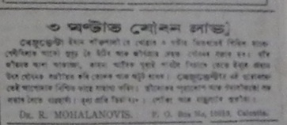

**Sadiniya Asomiya, 24th may 1947, pg 3**

***Joi Chemical Works***

**It is an advertisement of *Bejuvelta* medicine which will make you feel younger and lively within three hours.**

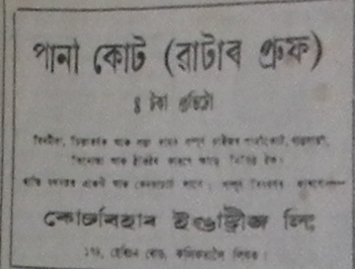

**Sadiniya Asomiya, 24th may 1947, pg 3**

***Kochbihar Industries Limited***

**It is an advertisement on rain coat**

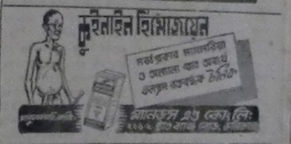

**Sadiniya Asomiya, 24th may 1947, pg 3 copy 4 and Sadiniya Asomiya, 31st may 1947, pg 6**

***Quinine Humojoen***

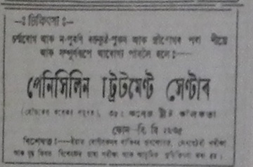

**Sadiniya Asomiya, 24th may 1947, pg 3 copy 5 and Sadiniya Asomiya, 31st may 1947, pg 6**

***Penicillin Treatment Centre***

**It is an advertisement of a clinical dispensary.**

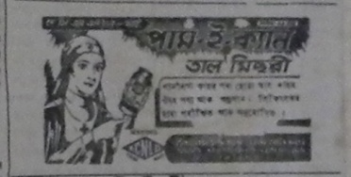

**Sadiniya Asomiya, 24th may 1947, pg 3 copy and Sadiniya Asomiya, 2nd August 1947, pg 6 and Sadiniya Asomiya, 31st may 1947, pg 6 and Sadiniya Asomiya, 26th july 1947, p3**

***Pam-e-Kayn***

**It is an advertisement on *Tal Misri*** (one kind of cough syrup)

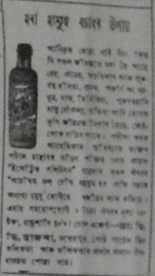

**Sadiniya Asomiya, 24th may 1947, pg 7**

***Mora Manuh Bosar Upai***

**It is an advertisement on some herbal medicine which proclaims that it can save a dying man.**

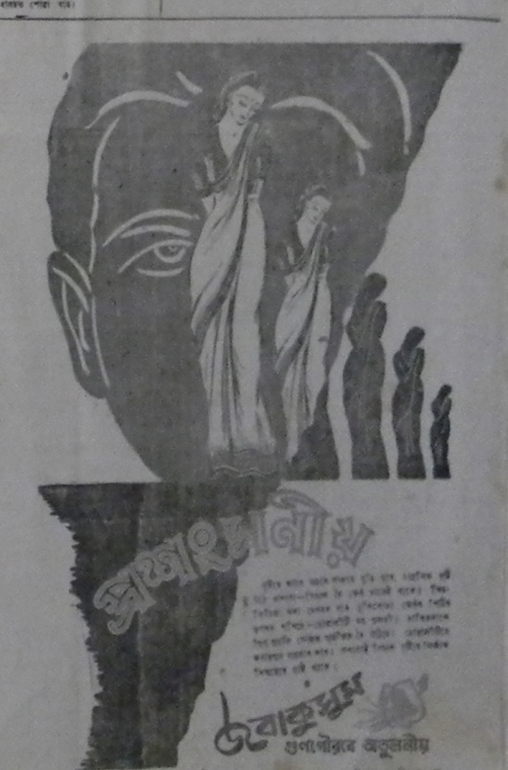

**Sadiniya Asomiya, 24th may 1947, pg 7**

***Jaibyakusum***

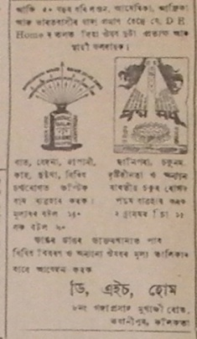

**Sadiniya Asomiya, 26th july 1947, pg 4 and Sadiniya Asomiya,6th feb 1948, pg 4**

***D.H.Home***

**It is an advertisement on medicine.**

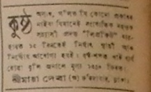

**Sadiniya Asomiya, 26th july 1947, pg 4**

***Shri Maya Deva***

**It is an advertisement on medicine to cure leprosy**

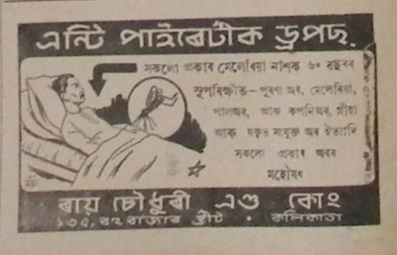

**Sadiniya Asomiya, 26th july 1947, pg 4 c2 and Sadiniya Asomiya, 6th dec 1947, pg4**

***Raichoudhury and Company***

**This is an advertisement on anti-pyretic drops**

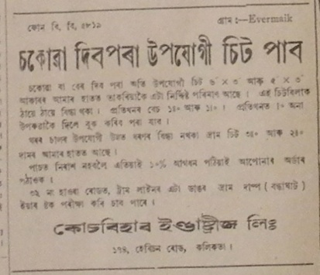

**Sadiniya Asomiya, 26th july 1947, pg 4**

***Kochbihar Industries Limited***

**It is an advertisement on hardware equipments.**

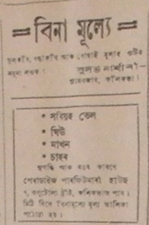

**Sadiniya Asomiya, 26th july 1947, pg 4**

***Sulabh Nursery***

**It is an advertisement on mustard oil, butter etc.**

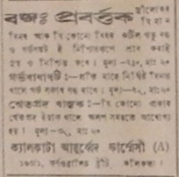

**Sadiniya Asomiya, 26th july 1947, pg 4**

***Calcutta Ayurvedic Pharmacy***

**It is an advertisement on ayurvedic medicine.**

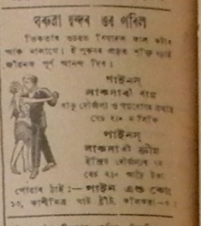

**Sadiniya Asomiya, 26th july 1947, pg 4 copy4 and Sadiniya Asomiya, 23rd August 1947, pg 5**

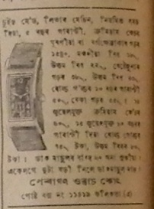

**Sadiniya Asomiya, 26th july 1947, pg 4**

***Paragon Watch Company***

**It is an advertisement on Swiss made watch.**

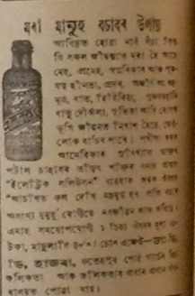

**Sadiniya Asomiya, 26th july 1947, pg 4 copy6 and Sadiniya Asomiya, 23rd August 1947, pg 8**

***Mora Manuh Bosar Upai***

**It is an advertisement on some herbal medicine which proclaims that it can save a dying man.**

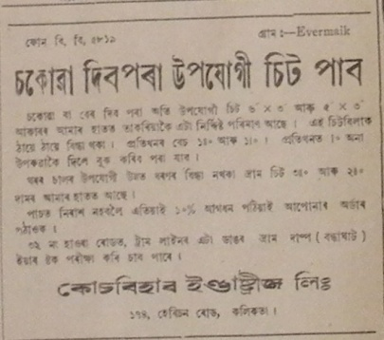

**Sadiniya Asomiya, 26th july 1947, pg 4**

***Kochbihar Industries Limited***

***Mora Manuh Bosar Upai***

**It is an advertisement on hardware quipments.**

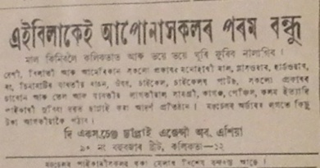

**Sadiniya Asomiya, 26th july 1947, pg 4**

***The Exchange Supply Agency of Asia***

**It is an advertisement on industrial goods with a home delivery facility**

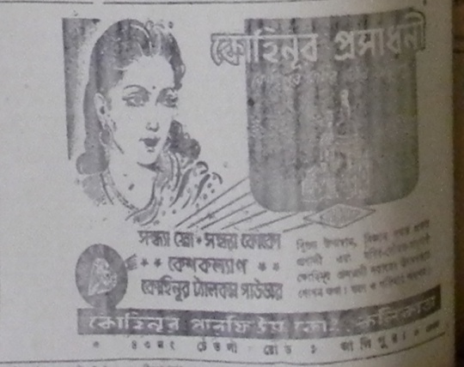

**Sadiniya Asomiya, 26th nov 1947 pg 6.**

***Kohinor Perfume Company***

**This is an advertisement on cosmetic products of the Kohinor Company.**

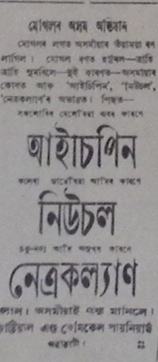

**Sadiniya Asomiya, 27th September 1947, pg8**

***Industrial and Chemical Pioneers***

**This is an advertisement on medicine like Neusol and Isepin.**

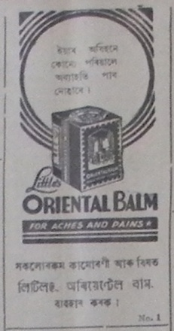

**Sadiniya Asomiya, 27th September 1947,**

***Sanatan Ayurvedic Ashram***

**This is an advertisement on *Oriental Balm* which is a pain relief balm.**

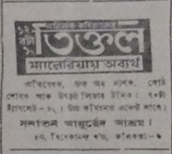

**Sadiniya Asomiya, 27th September 1947, pg8**

***Tiktol***

**This is an advertisement on anti-malarial medicine.**

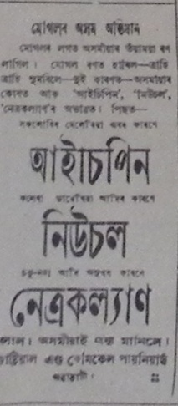

**Sadiniya Asomiya, 27th September 1947, pg8**

***Industrial and Chemical Pioneers***

**This is an advertisement on medicine like Neusol and Isepin.**

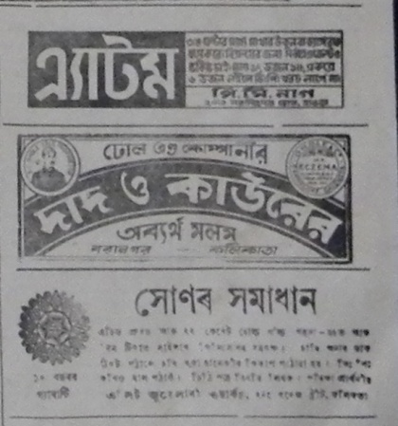

**Sadiniya Asomiya, 28th feb , 1948. pg3**

***Dhol and Company; Dada and Kaur***

**This is an advertisement on *Atom*, an ointment.**

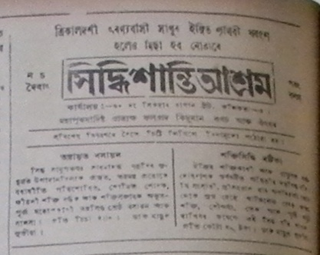

**Sadiniya Asomiya, 30th August 1947, pg2**

***Siddhisantiashram***

**This advertisement is about magico-ritualistic and herbal medicine.**

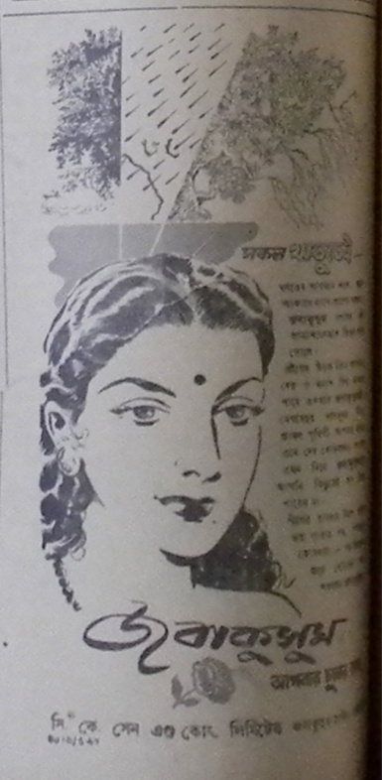

**Sadiniya Asomiya, 30th August 1947, pg2**

***C.K.Sen and Company***

**This is an advertisement on *Jobakusum* hair oil**

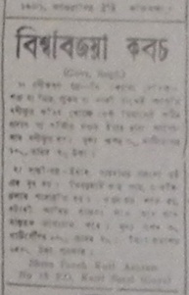

**Sadiniya Asomiya, 30th August 1947, pg 3**

***Biswabijaya Kabas***

**This is an advertisement on amulets**

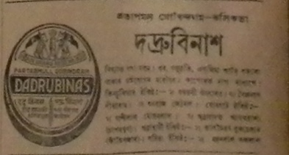

**Sadiniya Asomiya, 30th August 1947, pg 3 and Sadiniya Asomiya, 2nd August 1947, pg 3**

***Dadrubinas***

**This is an advertisement on herbal medicine**

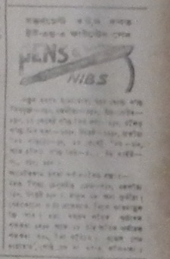

**Sadiniya Asomiya, 30th August 1947, pg 3**

***Pens & Nibs***

**It is an advertisement on U.S.A. fountain pen**

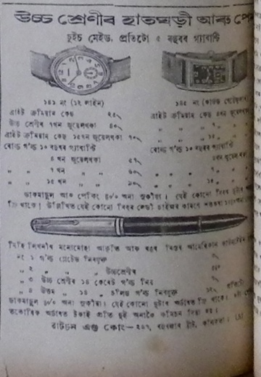

**Sadiniya Asomiya, 31st may 1947, pg 6**

***Watson and Company***

**This is an advertisement on high quality swiss made wrist watch and pen.**

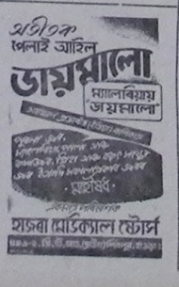

**Sadiniya Asomiya, 31st may 1947, pg 6**

***Hazra Medical Stores***

**This is an advertisement on anti-malarial medicine *Jaimalu***

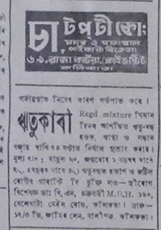

**Sadiniya Asomiya, 31st may 1947, pg 6**

***Chatap.T.Company***

**This is an advertisement on *Ritukari* medicine**

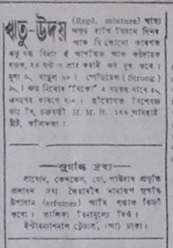

**Sadiniya Asomiya, 31st may 1947, pg 6**

**This is an advertisement on *Rituudoi* and *Sugandhi Drabya***

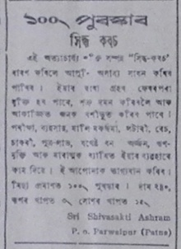

**Sadiniya Asomiya, 31st may 1947, pg 6**

**This is an advertisement on *Siddha Kabas*, one kind of medicinal product of *Sri Shivasakti Ashram***

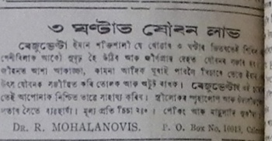

**Sadiniya Asomiya, 31st may 1947, pg 6**

***Joi Chemical Works***

**It is an advertisement of *Bejuvelta* medicine which will make you feel younger and lively within three hours.**

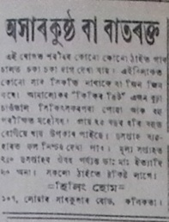

**Sadiniya Asomiya, 31st may 1947, pg 6**

***Healing Home***

**It is an advertisement of a clinic to cure diseases like *akharkustha* or  *batrakta***

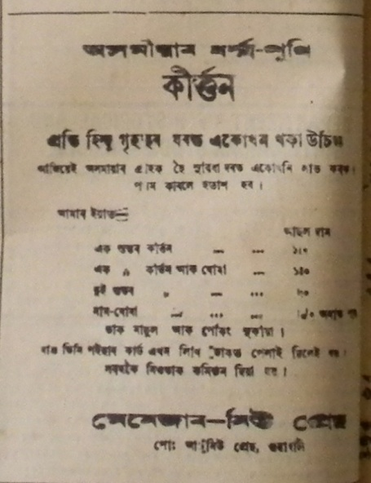

**tinidiniya asomiy a27 april 1934 pg 8**

***Manager New Press***

**It is an advertisement on *Kirtan, the religious scripture of Assamese-Hindus***

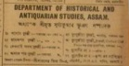

**Tinidiniya Asomiya.6 march 1934, pg 7 and 13th march 1934 pg 8**

***Department of Historical and Antiquarian Studies, Assam***

**It is an advertisement of above mentioned department regarding its publications and library collections.**

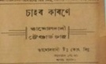

**Tinidiniya Asomiya.6 march 1934, pg 7**

***Tamolbari Tea Company Limited***

**It is an advertisement on *Tamolbari Standard Tea***

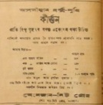

**Tinidiniya Asomiya.6 march 1934, pg 8 and 6 and 13th march 1934 pg 8**

***Manager New Press***

**It is an advertisement on *Kirtan, the religious scripture of Assamese-Hindus***

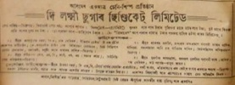

**Tinidiniya Asomiya.9 march 1934, pg 8**

***The Laxmi Sugar Syndicate Limited***

**It is an advertisement on sugar.**

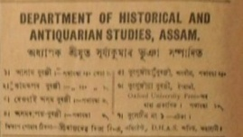

**Tinidiniya Asomiya.18 puh, 1855 saka, pg 7**

***Department of Historical and Antiquarian Studies, Assam***

**It is an advertisement of above mentioned department regarding its publications and library collections.**

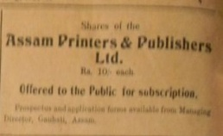

**Tinidiniya Asomiya.18 puh, 1855 saka, pg 7**

***Assam Printers & Publishers Limited***

**This is an advertisement on share holding.**

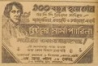

**Tinidiniya Asomiya.27 feb, 1934, pg6 and 8 and 16 march 1934, pg 8**

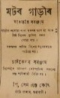

**Tinidiniya Asomiya.1934. 23 march pg 6 and 3rd april pg7**

***P.Sen and Company***

**This is an advertisement on motor car spare parts**

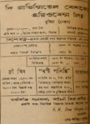

**Tinidiniya Asomiya.1934. 30 march pg 8**

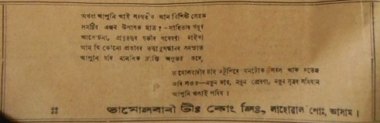

**Tinidiniya Asomiya. 2nd january, 1934, pg6**

***Tamolbari Tea Company Limited, Lahoal, Assam***

**This is an advertisement on tea.**

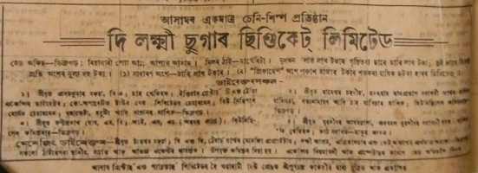

**Tinidiniya Asomiya. 2nd january, 1934, pg8**

***The Laxmi Sugar Syndicate Limited***

**It is an advertisement on sugar.**

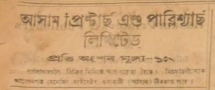

**Tinidiniya Asomiya. 2nd january, 1934, pg8**

***Assam Printers & Publishers Limited***

**This is an advertisement on share holding.**

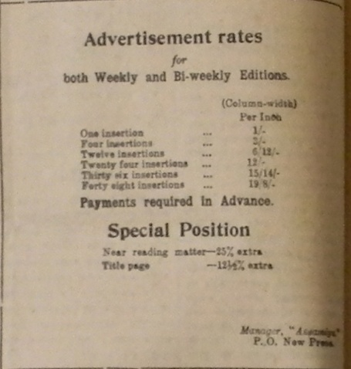

**TinidiniyaAsomiya PartII. 27 april, 1934, pg8**

***Asomiya***

**This is an advertisement regarding advertisement rates of both weeky and bi-weekly editions of Assamese news paper, *Asomiya.***